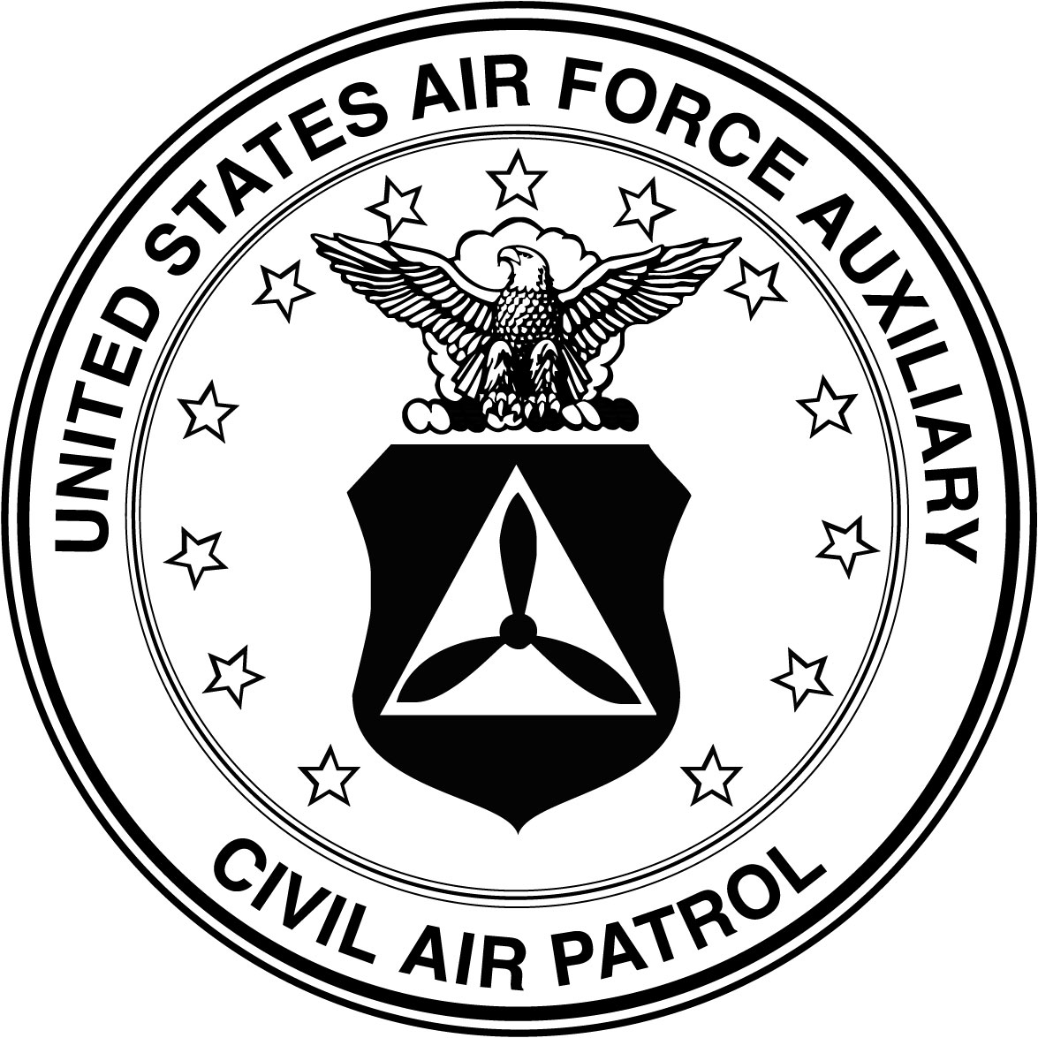
19 SEPTEMBER 2015
HEADQUARTERS OREGON WING
CIVIL AIR PATROL
UNITED STATES AIR FORCE AUXILIARY
28735 Grumman Drive
Eugene OR 97402-9542

MEMORANDUM FOR RECORD
FROM: OR-001/CC
SUBJECT: Participation Letter
1. The following individuals have participated in the 2015 Oregon Wing Conference, McMinville OR from 18-20 September 2015.

GRADE NAME
COL JOHN LONGLEY
LT COL TED TANORY
LT COL JOHN BARRINGER
C/SSgt JOAN SNUFFY

2. Transportation to or from such activity is not the responsibility of CAP and is provided "as available." Privately owned vehicle travel to or from such activity is performed strictly at the members' own risk (reference CAPR 77-1, Para 6c and CAPR 52-16, Para 8-10) and is not under CAP direction and control. Parents of cadets will be advised.

JOHN R. LONGLEY JR., Colonel, CAP
Commander
NOTES:
1) CAPID numbers are not required on a participation letter.
2) Participation letters are approved by a unit commander or individual designated on a personnel authorization.
3) A best practice is keeping these electronically in unit records, and filing copies in the personnel folders for each individual listed on it.
4) Paragraph 2 is “boiler plate” from CAPR 10-3, there’s no need to change it.
5) You’re welcome to use this document as a template. Be sure to update:
A) Date document prepared;
B) Specify, “have participated” or “will participate;”
C) Name, location, and date of activity;
D) Update the headquarters/level information in the header & “From;”
E) Be sure to delete this text box with notes.

