Recruiting & Retention Officer  OJT Workshop |  | 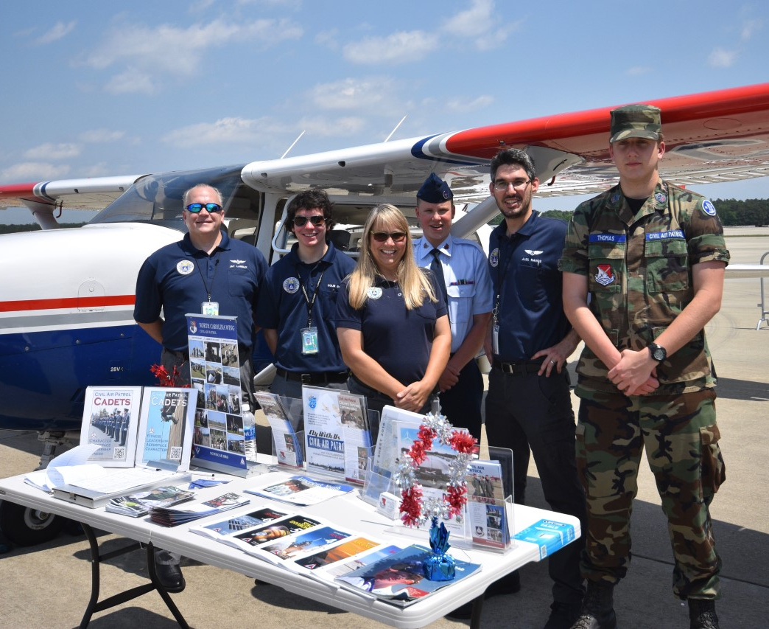
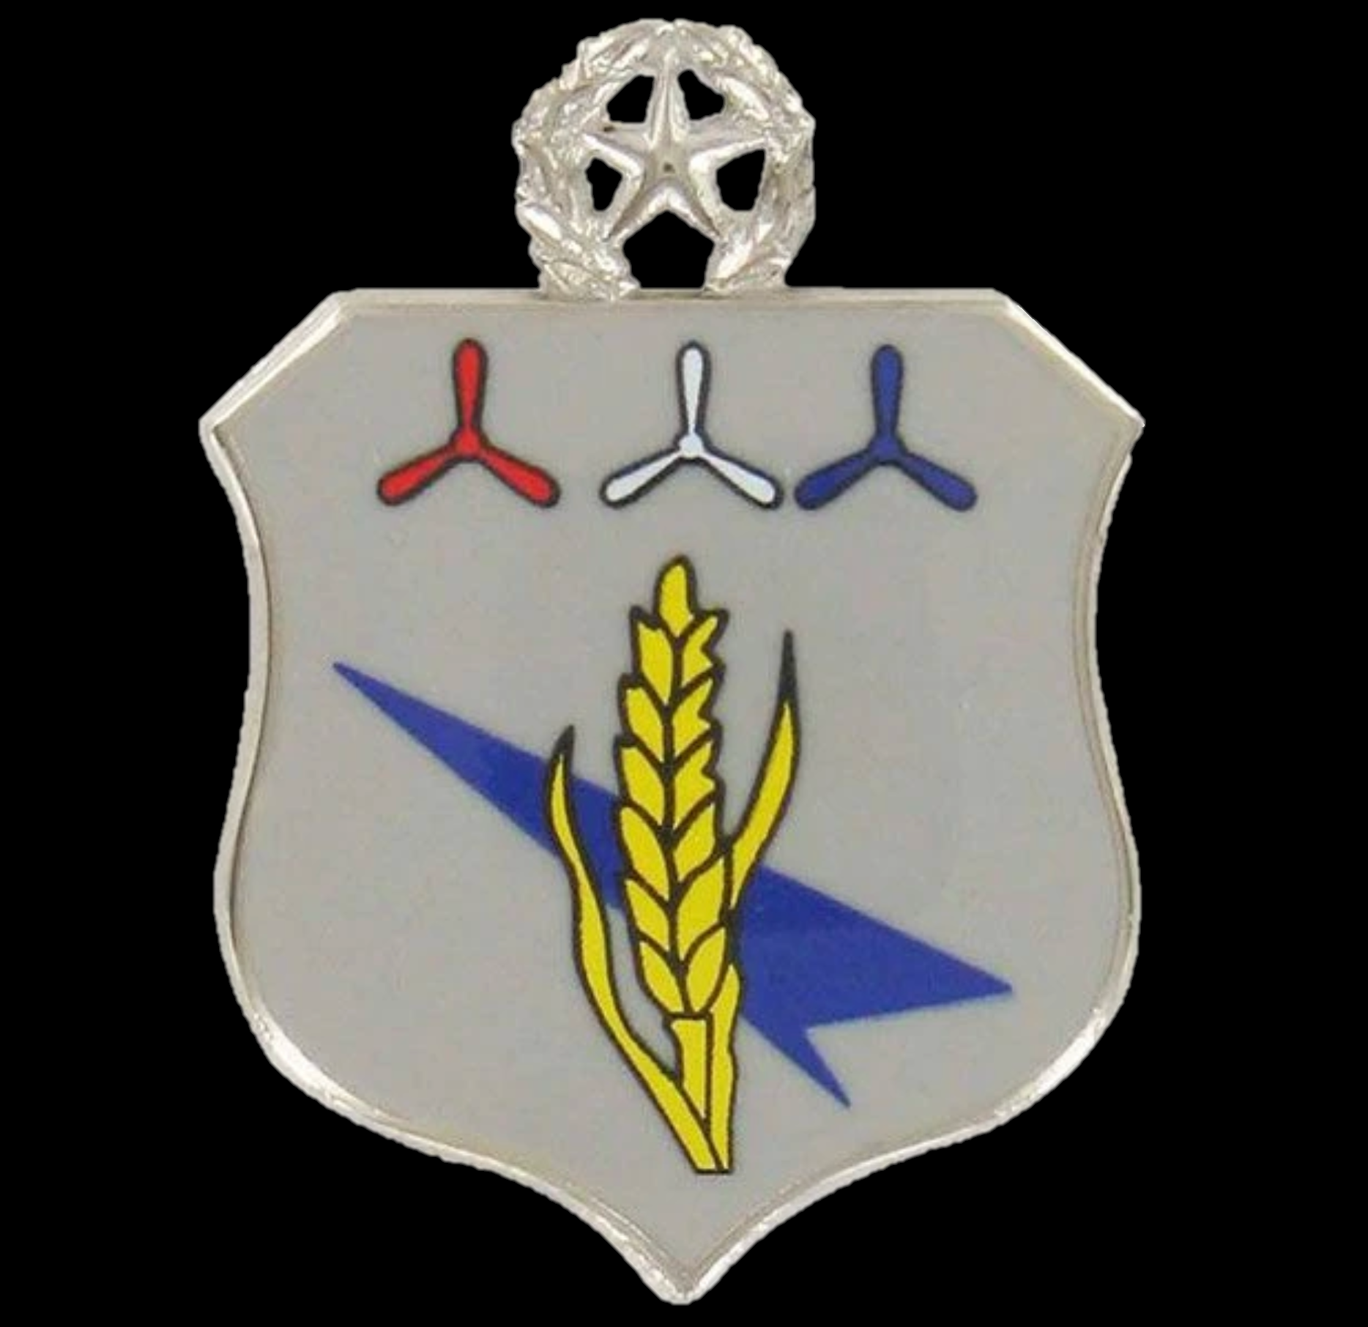 |  | Workshops will be held by video conference between  1800 – 1930 hrs  (Pacific Daylight Time)  For the meeting link,  please RSVP via email to:  Lt Col Ed Bos, CAP  edward.bos@orwgcap.org
April 24, 2020  Topics:  - Position Overview  - Evolution of CAP Culture  - Annual Planning  - Prospecting | May 1, 2020  Topics:  - Cohort Recruiting  - Year-Round Recruiting  - Unit Recruiting Incentives |  | May 8, 2020  Topics:  - Recruiting Skills  - Training Resources  - Starting New Units
Part of the Oregon Wing OJT Workshop Series
10 April 2020

Dear Civil Air Patrol Airman,
You’re invited to join us for a 3-part workshop series to learn about Recruiting and Retention from some of the most experienced recruiting personnel in CAP. Lt Col Ed Bos is hosting an online opportunity co-led by the current and emeritus CAP Recruiting and Retention Managers, Major Michael Moore and Col Darin Ninness.
These workshops will take place using the Zoom online meeting platform on
24 April, 1 May, and 8 May, between 1800 and 1930 hours (Pacific Daylight Time). Space is not limited, but RSVP is required to obtain the Zoom Meeting information and other workshop read-ahead information.
In addition to approximately 4.5 contact hours, this course will include some self-study, several job aids that participants can add to their toolkit, and opportunities to role-play typical situations one may find themselves in while conducting recruiting operations.
Participation is open to all interested CAP members, including Cadets. When organizing this workshop, we determined that many CAP members may benefit from this information, and not just appointed Recruiting and Retention Officers.
We are looking forward to some outstanding training and professional development for all the CAP personnel who choose to participate. Questions, comments, and recommendations should be emailed to Lt Col Ed Bos at edward.bos@orwgcap.org.
