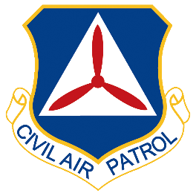
Want to Join the Civil Air Patrol?
Sign up for more information:
Name | Email | Phone | Zip | Age 18+?  Y/N | Pilot?  Y/N | Notes:

