Group/Squadron Virtual Meeting
Guide for Virtual Group/Squadron Meetings
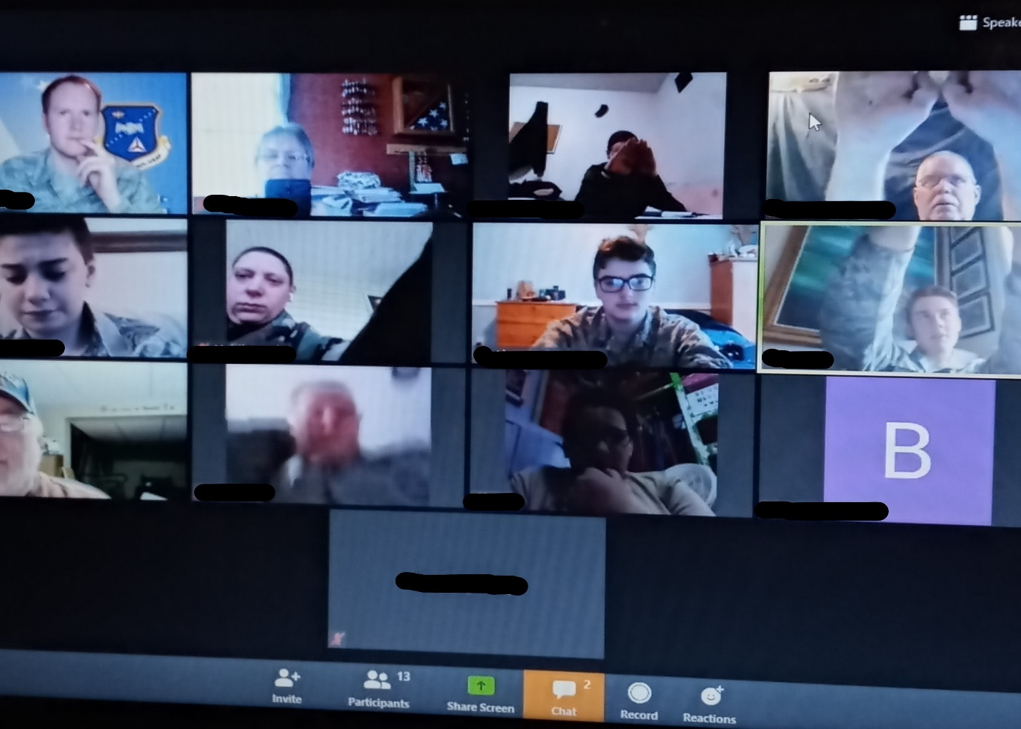
CAPP 14 March 2021
Table of Contents
Topic Page
Preface…………………………………………………………………………………………………………………3
Foreword……………………………………………………………………………………………………………..4
The Meeting…………………………………………………………………………………………………………5
How It Works……………………………………………………………………………………………………….5
Agenda…………………………………………………………………………………………………………………7
Options………………………………………………………………………………………………………………..8
Attachment 1……………………………………………………………………………………………………….9
Attachment 2……………………………………………………………………………………………………..10

Preface

This pamphlet is designed to guide members on how to hold a successful
virtual group/squadron meeting when holding an in-person meeting is not possible.

The purpose of the virtual group/squadron meeting is to be able to keep the weekly meeting going and to help the cadets and senior members to accomplish what the need for promotions and training. It also works good when you have several small squadrons that need help.

This is only a guide on conducting the meeting and the schedules in the attachments may be changed to meet your needs.

This virtual meeting has been tried and the members like it.

Foreword

Virtual meetings have several different purposes. One is that it is a way to meet when it is not possible to have a meeting in person. The second purpose is for the squadrons that do not have enough active members to participate in a meeting. In a virtual meeting for your wing or group, you can have as many squadrons as you want. Another purpose is for the members to interact with other members of the wing or group. In doing this, members will get to know other members, especially new members.

Purpose of This Guide
The purpose of this guide is to help run a successful meeting. The meetings can be informational and fun. This guide is to give an idea on how to run the meetings. Changes can be made wherever you feel the need to.

The Meeting

A starting point is to know what you want to accomplish during you meeting. The senior side of the meetings can be any helpful instruction, or a topic of interest to them. The cadet side of the meetings must include character development, leadership, and aerospace lessons.
A group/squadron meeting can be held once a week or every two weeks or monthly, if that is preferred. The meeting includes all the squadron in the wing or group. Squadrons may opt to not participate in these meetings. Some squadrons may prefer to attend the virtual meeting and also hold an in-person meeting, if they are permitted. If squadrons chose to do both meetings weekly the lessons will be done in the group/squadron meeting, which will give in person meetings time for hands on projects, such as rocket building, practicing drill and doing physical fitness and drill testing.
This concept will work for small squadrons or ones that are having problems and need more guidance.

How it Works

A planning meeting should be held to set up your meeting format. The planning committee for the meetings will be:
- Group Command Staff
- Group Commander
- Chief of Staff
- Deputy Commander
- Squadron Commanders
- Squadron Cadet Commanders
- CAC Council Officers
- The CAC council officers will be called cadet command staff for the virtual meetings.
The virtual meeting will be held on Zoom. Two separate accounts will be helpful as this makes it possible to record both the cadet and the senior sessions.
The meeting days will alternate every week Monday through Thursday to try to accommodate all members. The following is the schedule for the meetings:
- Week one Monday
- Week two Tuesday
- Week three Wednesday
- Week four Thursday
- Week five Monday
The time of the meeting will be from 1830 to 2030 hours.
The meetings will be hosted by a squadron commander and a cadet commander. The commanders will be from different squadrons and will change each week on a rotation. The rotation will depend on how many squadrons are in the group or wing. Rotating the commanders and cadet commanders will give the chance to work with different squadron leaders and see how they conduct their meetings.
The group cadet command staff will be available to help the cadet commander with any problems, or anything they need help with.
The meeting hosts for the week will decide what the topics for the lesson will be. Topics for the cadets will include the following each month:
- Character Development
- Leadership
- Aerospace
- Emergency Services

The topics for seniors will be:
- Education and training
- Other subjects of interest
Commanders and cadet commanders will have the option of:
- Having members from any squadron help with the meeting lesson
- The commander may need help if they do not have a lot of knowledge in the subject, they are teaching that week. For example, trying to teach ground team training when they are not interested in search and rescue. This will help to get other members involved in the meeting.
- Inviting guest speakers
The topics for the week should be filled in on a quarterly schedule at least a month in advance. This will allow other commanders to know what topics are already taken. (See attachment 1)
A quick safety briefing should be given at the beginning of each meeting.

Agenda

A typical meeting session should look like this:
- 1815-1830 Open discussion among members
- 1830-1840 Opening Ceremony/Cadet Commander
- Cadet Oath
- Safety Pledge
- Honor Code
- Pledge of Allegiance
- 1840-1850 Opening remarks/Introduction of guests/Group
Commander
- 1850-2010 Lessons/Cadets breakout
- 2010-2015 Cadets return to main room
- 2015-2025 Kahoot or promotions
- 2025-2030 Closing

Attachment 2 shows a weekly meeting schedule.

The second meeting of the month will be Character Development. Promotions will be recognized at this meeting for those promoting.
Uniform of the day will be ABU’s. Senior members may opt for the polo shirt. The second meeting of the month will be dress uniform.

Options
Once meetings are not required on a weekly basis, they may be held bi-weekly or monthly. This meeting would be a good time to have a guest speaker and be used for recognizing promotions during the month.

Attachment 1 Monthly Schedule

Date | Day of Week | Command |  | UOD | PT Warmup | Opening  Emphasis | Education Block 1 | Education Block 2
1-Feb-2021 | Monday |  |  | ABU/BDU | Cadet-10 Min | Safety
 |  | Cadet commander | C/Capt Coburn
 |  | Senior | Lt Hall |  |  | Lt. Hall | Resilience Training | Resilience Training
9-Feb-2021 | Tuesday |  |  | DRESS | Promotions | Character Develop | Leadership Lesson
 |  | Cadet commander | C/Lt Rhoades |  |  | Excellence | Ethical decision making | Kahoot
 |  | Senior | Capt Coburn |  |  | Using G Suite |  | PD Training Plans - CAP university PD link to help SM with plans
17-Feb-2021 | Wednesday |  |  | ABU/BDU | Cadet-10 Min | Safety | Ground Team Tng | Ground Team Tng
 |  | Cadet commander | C/Maj Gillette |  |  |  | 24 and 72 hour pack | SQTR
 |  | Senior | Lt Col Brown |  |  |  | Level 2 | PD Training Plans - CAP university PD link to help SM with plans
27-Feb-2021 | Thursday |  |  | ABU/BDU | Cadet-10 Min | AE Current Events | Aerospace | Aerospace AEX
 |  | Cadet commander | C/Capt Curran |  | Ice Breaker - C/CMSgt Kaltenbach |  | Aerospace Leaders of the 20th Century | Kahoot
 |  | Senior | Capt Rosell |  |  | Internet Security

Attachment 2 Weekly Schedule

Weekly Group/Squadron Meeting Schedule
Date: 17 Feb 2021 | Time 1800-2030 |  | UOD: ABU/BDU
Group Commander: | Col Jack Flamingo |  | PA-700
Deputy Commander: | Lt Col Tim Brice |  | PA-700
Chief of Staff | 1st Lt Martin Ball |  | PA-700
Sqn Commander: | Lt Col Tim Brice |  | PA-555
Cadet Command: | C/Maj Rachel Giller |  | PA-491
C/Support:: | C/1st Lt Matt Stormer |  | PA-305
C/Support | C/1st Lt Elsa Dawn |  | PA-679
Time | Session |  |  |  | Link
1815-1830 | Main Session-Open Discussion |  |  |  | All Connect
1830-1840 | Opening Ceremony-C/Maj Rachel Giller
1840-1850 | Opening Remarks-Col Jack Flamingo
1850-1855 | Breakout for Cadets |  |  |  | Cadets Connect
1855-1955 | Senior Member Education and Training
 | Cadet Session
1855-1955 | 24-72 Hour Pack Review
 | SQTR Overview
1955-2000 | Cadets return to main room |  |  |  | Connect
2000-2020 | Kahoot
2020-2030 | Closing Ceremony
Track Key | Senior | Cadets | All

