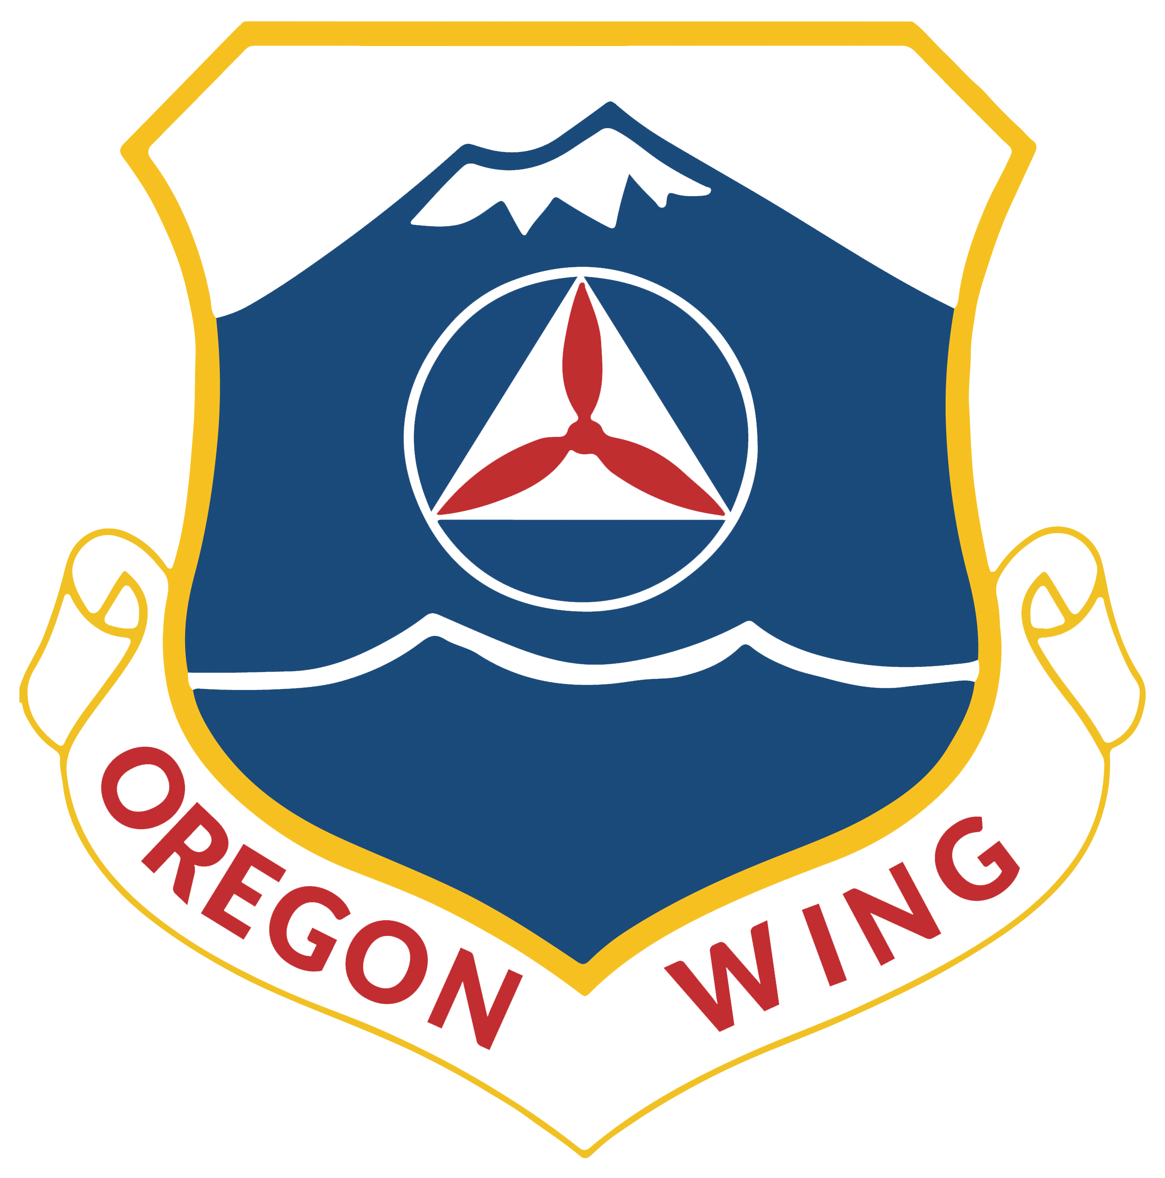
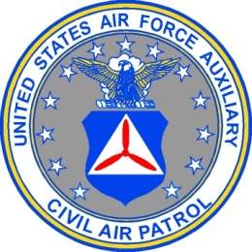
HEADQUARTERS OREGON WING
CIVIL AIR PATROL
UNITED STATES AIR FORCE AUXILIARY
28735 Grumman Drive
Eugene OR 97402-9542

15 August 2019

MEMORANDUM FOR ORWG PERSONNEL

FROM ORWG/CC

SUBJECT: Soliciting Donations Items for Conference Auction

1. On 13 August 2019, an email was sent out requesting donation items for a silent auction to be held at the upcoming Oregon Wing/Pacific Region conference.

2. In order to support those members who are asking their community to support our new scholarship fund, I have directed that the attached documents be prepared for the wing:

a. A donation letter, with details for potential donors to learn about the scholarship fund we are auctioning items for, and

b. A donation tracking sheet, for the committee preparing the items for auction.

3. If you have any questions or recommendations regarding this process, please do not hesitate to contact the auction POC, Lt Col Ed Bos, at edward.bos@orwgcap.org or (907) 444-5679.

//e-signed// William G Ray
WILLIAM G. RAY, Col, CAP
Commander

Attachments:
1. Donation Letter
2. Item tracking sheet

HEADQUARTERS OREGON WING
CIVIL AIR PATROL
UNITED STATES AIR FORCE AUXILIARY
28735 Grumman Drive
Eugene OR 97402-9542

15 August 2019

Greetings!

I am Bill Ray, the statewide commander for the Civil Air Patrol.

In order to support our members are we conduct search and rescue missions, disaster relief activities, and the most exciting youth-development program in the country, we are asking for your support.

Major Randy Ireson was an amazing pilot, teacher, mentor, and friend to many of us. We lost him to cancer in 2017 and have been coordinating with his loved ones to endow a scholarship fund in his memory. We will be holding a silent auction at our annual conference on October 5, 2019, and your donation of an auction item would mean a great deal to us all.

This fund will provide support for Civil Air Patrol Cadets (ages 12-20), allowing these young community leaders to attend activities and have experiences that they would not otherwise be able to take advantage of. From a week-long intensive rocketry camp in Oregon, to the Civic Leadership Academy in Washington DC, our Cadets have a chance to learn through rigorous academics and unique hands-on instruction. It is our intent to ensure that funding is not a barrier that would prevent these young men and women from reaching their full potential in our program.

Your support is greatly appreciated. In addition to any gift certificate, item, or appropriate donation, we ask that you consider giving some business cards, bumper stickers, or other collateral that we can put next to your donation item. We will have approximately 350 conference attendees from throughout the Pacific Region and across the country. With most of the attendees being from Oregon and Washington, we want to show our appreciation by sharing a little about your company or organization alongside your gift.

Thank you very much for your support, and if you ever want to learn more about the Oregon Wing of the Civil Air Patrol, please don’t hesitate to send me an email. I can be reached at william.ray@orwgcap.org.

Very respectfully yours,

William G Ray
Col William G. Ray, CAP
Oregon Wing Commander
Silent Auction Item Tracking Sheet
For the Randy Ireson Memorial Scholarship Fund
Donations Should Be Identified and Submitted by 15 SEP 2019
Person Asking for Donation:
Are you a CAP Member: ___ Yes ___ No
Donor Representative Name:
Donor Company Name:
Mailing Address:
Physical Address:
EMAIL:
Phone Number:
Description of item or service being donated:
Approximate Retail Value: $ ____________________
Restrictions/Additional Notes/Etc:

