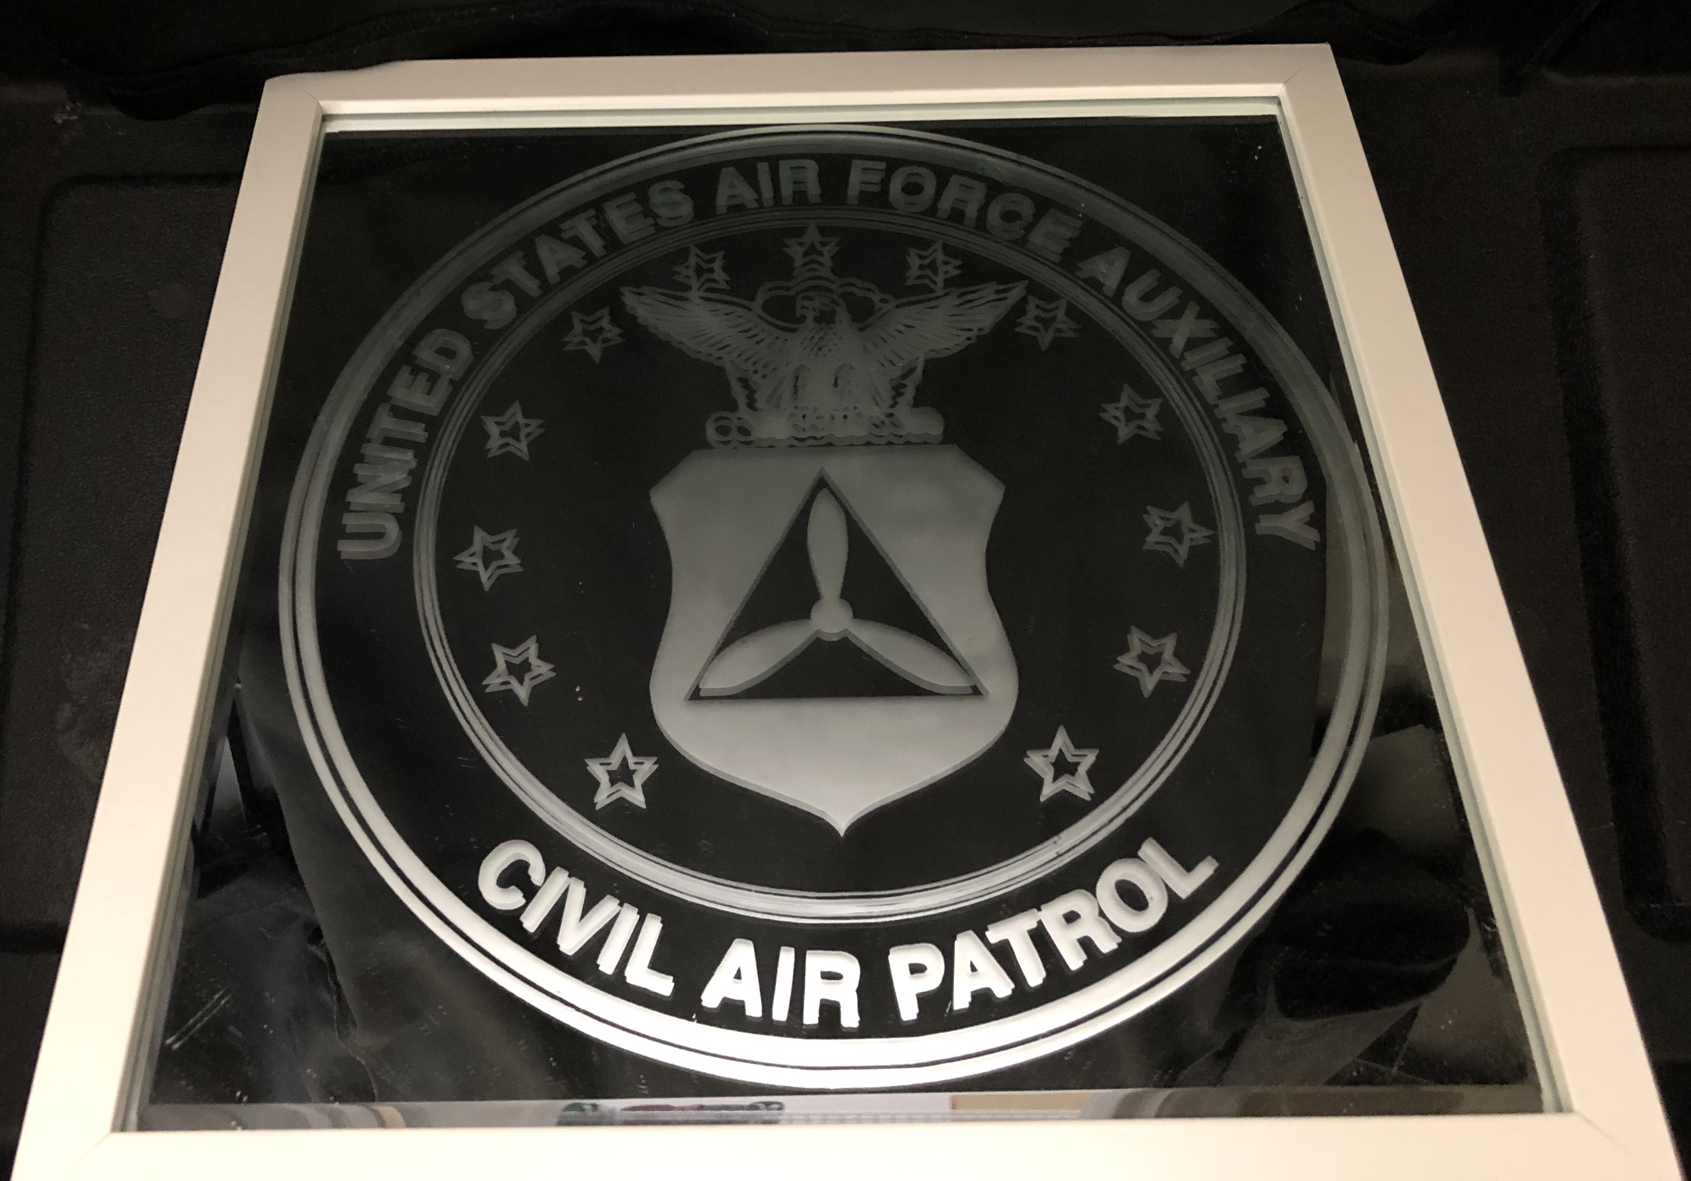  CAP Seal Etched on Mirror  The Civil Air Patrol seal is etched on this 12” x 12” mirror, and framed for hanging in your home or office.  If you bid on this item and don’t win, feel free to email and let us know you’re interested in making a donation for another, similar, mirror.  This item is valued at $100.00.  The minimum bid is $25.00, and the minimum bid increase is $3.00  There are no restrictions on this item.  Generously Donated by the Oregon Wing Headquarters | Bid Amount: $_______  25.00.  Name: _____________  Bid Amount: $_______  Name: _____________  Bid Amount: $_______  Name: _____________  Bid Amount: $_______  Name: _____________  Bid Amount: $_______  Name: _____________  Bid Amount: $_______  Name: _____________  Bid Amount: $_______  Name: _____________  Bid Amount: $_______  Name: _____________  Bid Amount: $_______  Name: _____________  Bid Amount: $_______  Name: _____________  Bid Amount: $_______  Name: _____________  Bid Amount: $_______  Name: _____________  Bid Amount: $_______  Name: _____________  Bid Amount: $_______  Name: _____________  Buy it now, for $125.00.
100.00

